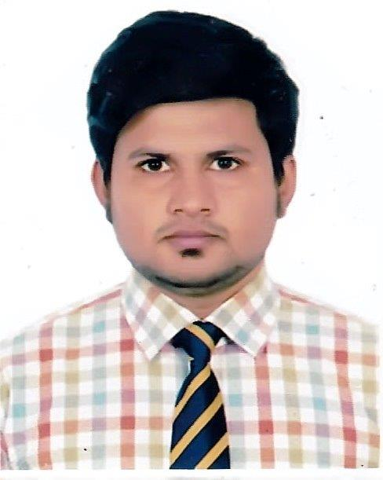 **SHABBIR HOSSAIN**

Dapa Idrakpur, Fatullah, Narayangonj.

**Mob:** 01676-723852

01930-740860

E-mail: [shabbir99@gmail.com](mailto:shabbir99@gmail.com)

Shabbirfs99@outlook.com

**Personal Statement:**

A recent honors degree in accounting from,looking to secure a Graduate Commercial Analyst position or similar to utilize my current analytical skills and knowledge and also help I to further develop these skills in a practical and fast-paced environment.

My eventual career goal is to assume responsibility for the analysis and implementation of all commercial data and actively contribute to the overall success of any business I work for.

**Education:**

**Bachelor of Business Administration (BBA).**

* National University
* (**Govt. Murapara** College))

Major Accounting

CGPA: 2.81 (Higher Second Class)

**Higher Secondary Certificate (HSC)**

Narayanganj University College

Business Studies

GPA: 4.10 (Frist Class)

**Secondary School Certificate (SSC)**

Fatullah Pilot High School

Business Studies

GPA: 4.19 (First Class)

* **Personal Details:**

Father’s Name : Md. Sharif Ahmed

Mother’s Name : Shewly Ahmed

Present Address : House # 2, Road # 1, Al-Aksha Mosjid Road, vill: Dapa Idrakpur, Fatulla, Narayangonj 1421.

Permanent Address : House # 2, Road # 1, Al-Aksha Mosjid Road, vill: Dapa Idrakpur, Fatulla, Narayangonj 1421.

Date of Birth : 20/01/1995

National ID No : 462 822 5080

Height : 5.5”

Sex : Male

Blood Group : A+

Health : Good

Nationality : Bangladeshi

Religion : Islam (Sunni)

Marital Status : Married

**Work Experience:**

**ICC World Cup T20 Bangladesh 2014.**

* Ticket Issue By NCC BANK (Motijeel Branch)
* Supervisor At Mirpur National Stadium (ICC World Cup 2014)

**FedEx Express Co Ltd.**

* **Customer Service & operation Department –May-17-2016 To Present.**

**Key Skills Gained:**

* Analytical and conceptual thinking, with a conscientious approach to managing workloads.
* Ability to handle, analyse and interpret complex data, before presenting it back based on the overall analysis made.
* Advanced problem solving and numeracy skills.
* Accomplished communication skills, both written and verbal, developed through numerous essays and presentations.
* Proficiency in all areas of Microsoft Office, including Access, Excel, Word and PowerPoint
* Good Communication Skill Both in English in Bangla

**Hobbies & Interests:**

Listening, Cool Song, Photography, Travelling, Cricket, Badminton Etc.



Signature:

Date: 08-11 -2020 SHABBIR HOSSAIN